Step 5: Develop or elaborate behavioral representation for a class or component

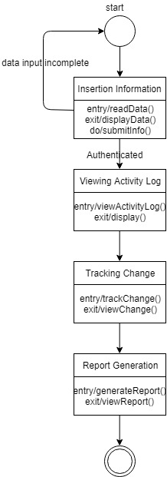

Figure: State chart fragment for “System Admin”

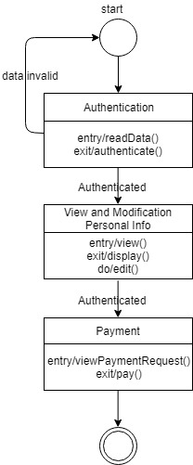

Figure: State chart fragment for “Student”

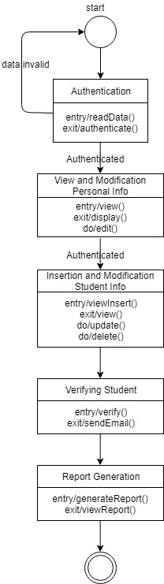

Figure: State chart fragment for “Registrar”

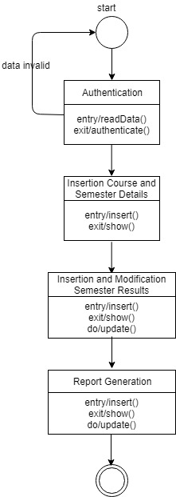

Figure: State chart fragment for “Program Officer”

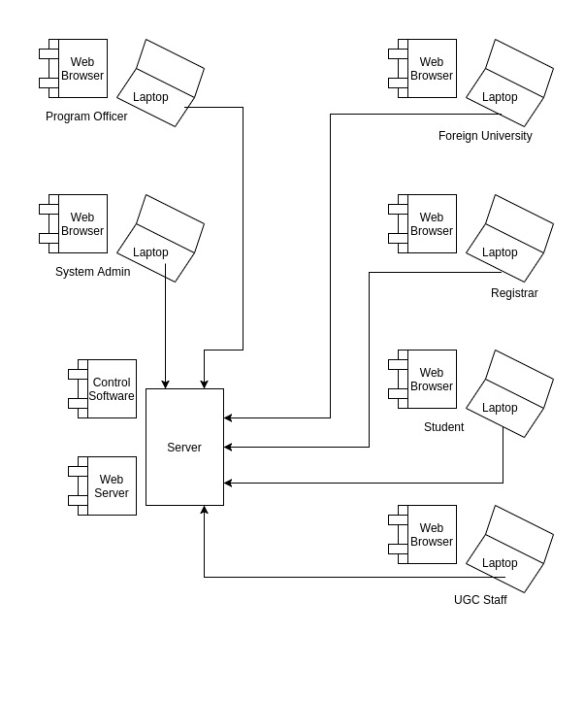Figure: State chart for OGRVS